CHAPTER 3: RESEARCH METHODOLOGY

3.1 Chapter Overview
This chapter outlines the comprehensive research methodology, architectural design, and implementation strategy employed to develop the "Intelligent Management Framework for Mitigating Social-Engineered Spam and Cyber Threats in University Social Groups." Addressing the limitations of current manual moderation techniques highlighted in Chapter 1, and building upon the theoretical foundations of natural language processing (NLP) and machine learning discussed in Chapter 2, this chapter provides a detailed blueprint of the system's construction.
The primary objective of this methodology is to seamlessly bridge the gap between static machine learning models and dynamic, real-time social messaging environments (specifically WhatsApp). To provide a structured and rigorous explanation, this chapter is divided into several core sections:
- Research Design and Methodology: The overarching software development lifecycle adopted for this project.
- Data Collection and Engineering: The strategy for compiling and synthesizing a cross-lingual "Manglish" dataset.
- Data Preprocessing Pipeline: The mathematical and algorithmic transformations applied to raw text.
- Machine Learning Engine Architecture: An in-depth look at the Random Forest and Support Vector Machine algorithms utilized for threat classification.
- System Architecture and Integration: The technical integration of Selenium WebDriver, the FastAPI backend, and the WebSockets presentation layer.
- System Evaluation Metrics: The mathematical criteria used to assess the framework's operational success.

3.2 Research Design and Methodology
Given the experimental nature of machine learning and the unpredictable structure of dynamic web applications (like WhatsApp Web), a traditional Waterfall methodology is insufficiently rigid. Therefore, this project adopts an Iterative Prototyping (Agile) Methodology. This approach allows for the continuous refinement of the machine learning models and the scraping algorithms based on continuous testing and evaluation.

3.2.1 Iterative Prototyping Phases
The development process is structured into five iterative phases, ensuring that each component of the framework—from data extraction to algorithmic prediction—is robust before full integration.
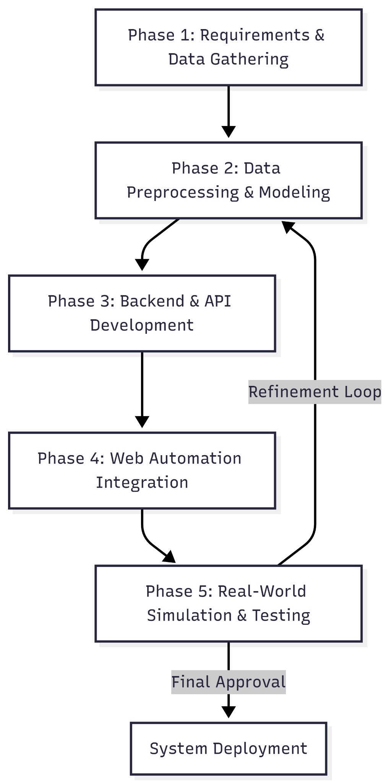
- Phase 1: Requirements and Data Gathering: Identifying the specific threat vectors targeting UTeM students (e.g., fake tuition fees, scholarship phishing). Gathering extensive datasets from Kaggle to represent these threats in both English and Malay.
- Phase 2: Data Preprocessing and Modeling: Developing the learning_engine.py module. This involves cleaning the text, building the TF-IDF vectorizer, and training the Random Forest and SVM classifiers.
- Phase 3: Backend and API Development: Constructing the asynchronous FastAPI server (app.py) to handle incoming data streams and serve as the central nervous system of the framework.
- Phase 4: Web Automation Integration: Scripting the radar.py module using Selenium WebDriver to interact with the WhatsApp Web DOM, extracting messages, and injecting mitigation warnings.
- Phase 5: Real-World Simulation and Testing: Deploying the integrated system in a controlled, simulated WhatsApp group to evaluate response latency, classification accuracy, and system stability. The feedback loop returns to Phase 2 for model retraining if false positives/negatives are excessively high.

3.3 Data Collection and Corpus Engineering
The foundation of any robust natural language processing system is its dataset. As identified in the literature review, commercial spam filters predominantly focus on standard English and fail to comprehend the linguistic nuances of Malaysian university students. This project requires a dataset capable of understanding "Manglish"—a complex code-switching dialect blending English syntax with Malay vocabulary and localized campus slang.

3.3.1 Sourcing Base Datasets
To overcome the lack of pre-existing Manglish cybersecurity datasets, a cross-lingual data aggregation strategy was executed utilizing Kaggle, a premier platform for data science resources.
- English Spam/Phishing Corpus: Datasets containing thousands of confirmed English social engineering attempts were sourced. These provided the model with a baseline understanding of universal psychological manipulation tactics (e.g., false urgency, financial enticement).
- Malay Scam Corpus (Bahasa Melayu): Datasets containing local Malaysian scam messages (e.g., "Macau Scam" transcripts, fake bank SMS) were sourced to capture local linguistic threat vectors (e.g., "akaun disekat", "tahniah anda menang").

3.3.2 Synthesizing the "Manglish" Phenomenon
The core innovation in this data engineering phase is the Cross-Lingual Aggregation Effect. The distinct English and Malay datasets were merged into a singular, unified training corpus (whatsapp_dataset.csv).
By training a single machine learning model on both pure English and pure Malay scam characteristics simultaneously, the algorithm learns the malicious semantic weights of words in both languages. Consequently, when the model is deployed and encounters a "Manglish" message—which is essentially a hybridized sentence (e.g., "Tolong click this link to update your UTeM portal immediately")—the vectorizer successfully identifies the malicious keywords ("click", "link", "update", "immediately") regardless of the specific language ratio used in the sentence.

3.4 Data Preprocessing Pipeline
Raw textual data extracted from instant messaging applications is highly unstructured and noisy. Before the text can be processed by the machine learning classifiers, it must undergo a rigorous, multi-stage preprocessing pipeline.

3.4.1 Preprocessing Workflow Diagram
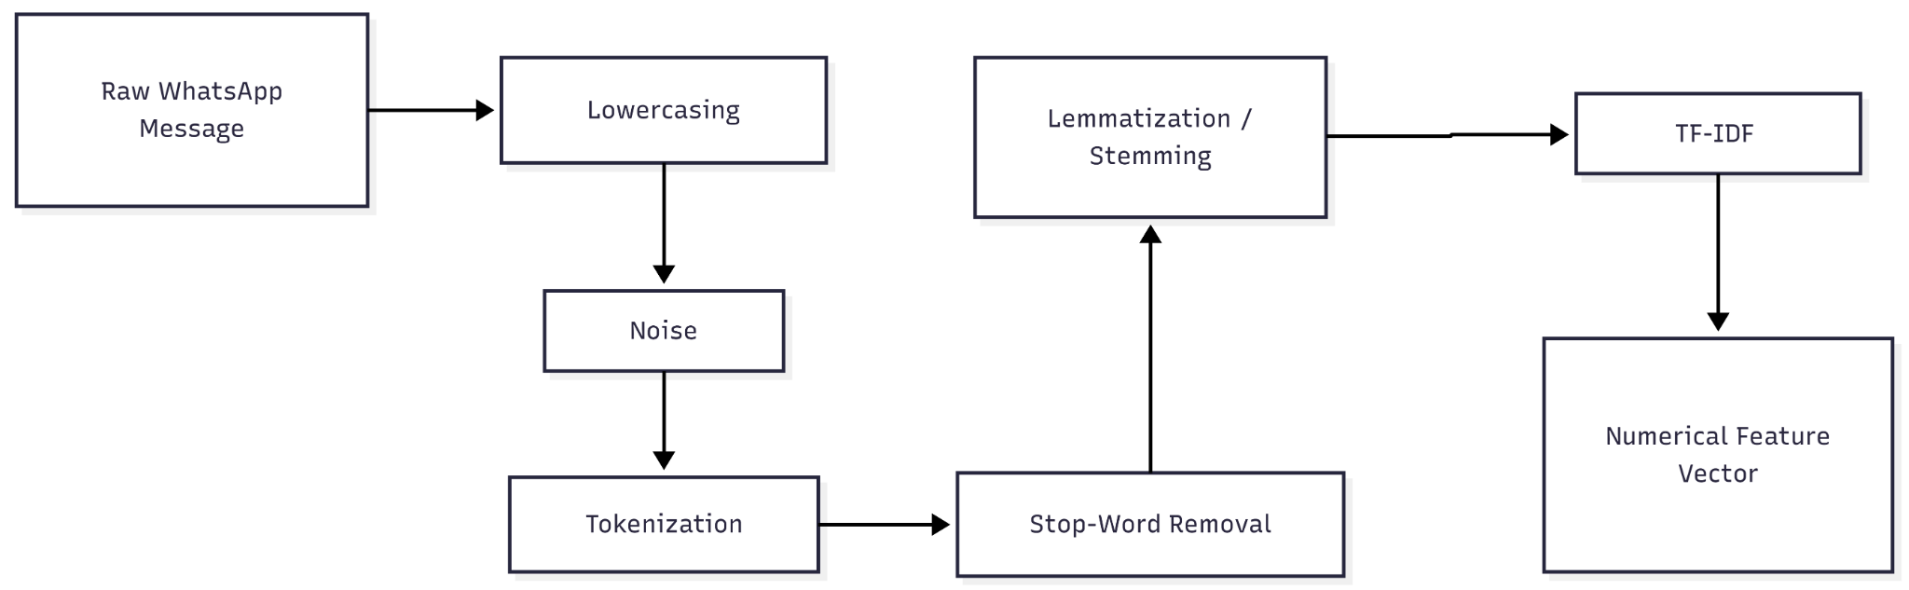

3.4.2 Noise Reduction and Normalization
Text from social groups often contains emojis, URLs, varying capitalizations, and irregular punctuation.
- Lowercasing: All text is converted to lowercase to ensure uniformity (e.g., "Urgent" and "urgent" are treated identically).
- Special Character Stripping: Regular expressions (Regex) are employed to strip away non-alphanumeric characters, except for necessary structural markers, to reduce the dimensionality of the feature space.

3.4.3 Stop-Word Removal
Stop-words are frequently occurring words that provide grammatical structure but carry negligible semantic weight regarding the intent of the message such as "is", "the", "and". Because the system operates in a Manglish context, a custom bilingual stop-word dictionary is utilized, combining standard English stop-words with standard Malay stop-words such as "dan", "yang", "kepada". This significantly reduces computational overhead and focuses the model on high-impact vocabulary.

3.4.4 Tokenization and Vectorization (TF-IDF)
Machine learning algorithms cannot process raw text strings; they require numerical input. This project utilizes the Term Frequency-Inverse Document Frequency (TF-IDF) vectorizer. TF-IDF evaluates how relevant a word is to a document within a collection of documents.
The mathematical formulation is as follows:
1. Term Frequency (TF): Measures how frequently a term occurs in a document .
2. Inverse Document Frequency (IDF): Measures the importance of the term across the entire corpus . It scales down the weight of terms that occur very frequently across all documents (like common slang) and scales up rare, highly indicative terms (like "password" or "bank").
3. TF-IDF Weight:
By applying TF-IDF, a localized campus scam message is transformed into a high-dimensional mathematical vector where suspicious keywords possess distinctively high numerical weights, allowing the machine learning algorithm to mathematically distinguish it from a normal student conversation.

3.5 Machine Learning Engine Architecture
The Logic and Processing Layer relies on the learning_engine.py module. This research employs Supervised Machine Learning, where the algorithms are trained on the pre-labeled datasets to recognize patterns associated with social engineering. Two primary algorithms are evaluated and utilized.

3.5.1 Random Forest Classifier (Primary Model)
The Random Forest algorithm is selected as the primary classification engine due to its exceptional performance on high-dimensional text data and its resilience to overfitting. Random Forest is an ensemble learning method that constructs a multitude of decision trees during the training phase.
Algorithmic Process:
- Bootstrapping: The algorithm selects random subsets of the training data (with replacement).
- Tree Generation: For each subset, a decision tree is constructed. At each node in the tree, only a random subset of the TF-IDF features is considered for splitting the data.
- Voting Mechanism: When a live message is ingested, it is passed down all generated trees. Each tree outputs a classification ("Threat" or "Safe"). The Random Forest outputs the class that receives the majority vote.
Because informal WhatsApp messages vary wildly in structure, a single decision tree would easily overfit to specific slang. By aggregating the decisions of hundreds of uncorrelated trees, the Random Forest provides a highly stable, generalized prediction.

3.5.2 Support Vector Machine (Baseline Model)
Support Vector Machine (SVM) is utilized as a comparative baseline model. SVM operates by mapping the TF-IDF vectors into an n-dimensional space and determining the optimal hyperplane that mathematically separates the "Threat" vectors from the "Safe" vectors with the maximum possible margin. While highly effective for binary text classification, SVMs can become computationally expensive with exceptionally large datasets, hence its role as a secondary validation model against the Random Forest.

3.6 System Architecture and Implementation
The true complexity of this research lies in integrating the static machine learning models with the dynamic, real-time environment of WhatsApp. Because Meta (formerly Facebook) strictly limits API access to WhatsApp groups—often requiring corporate verification and imposing read-limits—this framework utilizes browser automation to simulate a human user, entirely bypassing API restrictions.

3.6.1 High-Level Architecture Diagram
The system operates across a decoupled, three-tier architecture ensuring that high-latency tasks like web scraping do not block high-speed tasks (like mathematical classification).
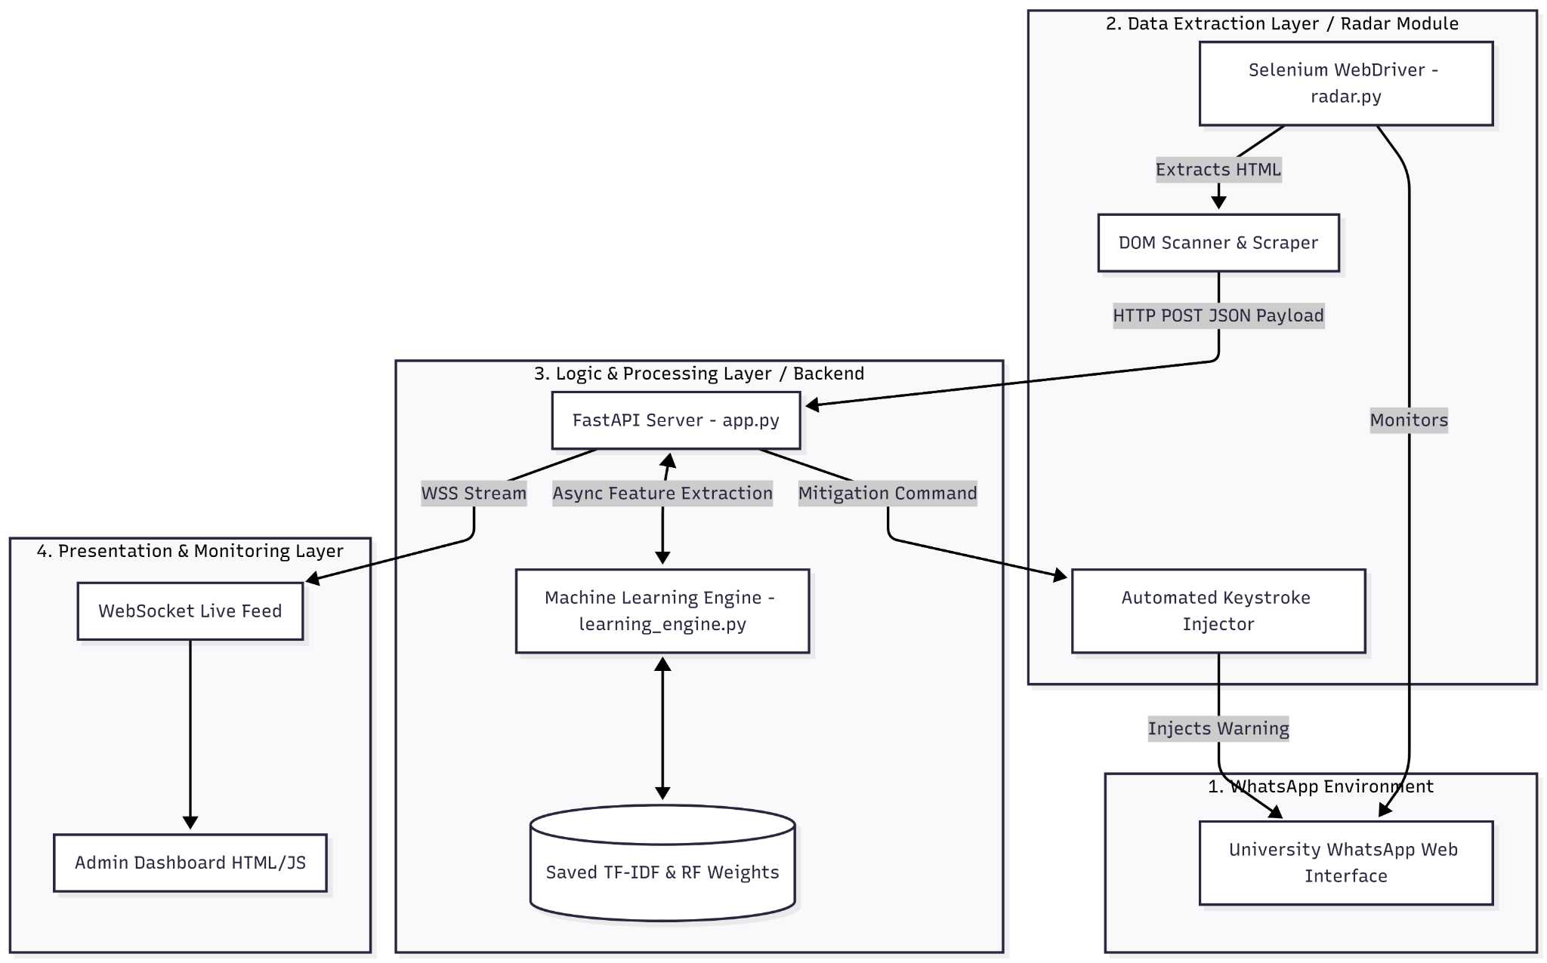

3.6.2 Data Extraction Layer: Selenium WebDriver
The radar.py module utilizes the Selenium WebDriver framework to control an instance of Google Chrome.
- Authentication: Upon launch, the system navigates to WhatsApp Web and awaits manual or session-cached QR code authentication.
- DOM Traversal: The script utilizes XPath and CSS Selectors to continuously monitor the Document Object Model (DOM). It targets the specific HTML <div> classes associated with incoming message bubbles.
- Extraction Loop: An infinite loop checks for state changes in the DOM. When a new message <span> is rendered by the browser, Selenium extracts the inner text and the sender's metadata. This data is instantly packaged into a JSON payload and fired to the backend via an HTTP POST request.

3.6.3 Logic and Processing Layer: FastAPI Backend
The app.py script utilizes FastAPI, a modern, high-performance web framework for building APIs in Python. FastAPI was explicitly chosen over traditional frameworks like Flask or Django due to its native support for ASGI (Asynchronous Server Gateway Interface).
Asynchronous Event Handling: When the Radar module sends a message payload, FastAPI receives it asynchronously. This means the server can accept hundreds of messages per second from heavily active university groups without crashing. The text is passed to learning_engine.py, which applies the saved TF-IDF transformations and executes the Random Forest .predict_proba() function.
If the calculated probability of a threat exceeds the defined safety threshold (e.g., ), the FastAPI server flags the payload and initiates the mitigation sequence.

3.6.4 Mitigation Protocol and Automated Response
The framework is not merely a passive monitoring tool; it is an active mitigation system.
- Command Generation: Upon detecting a high-risk payload, the FastAPI backend returns an immediate HTTP response to the radar.py script containing a mitigation directive.
- UI Injection: The Selenium WebDriver pauses its extraction loop, locates the WhatsApp Web text input box via its precise XPath, and utilizes the send_keys() method to type a rapid, localized warning. Example like ⚠️ [SYSTEM ALERT]: The previous message has been flagged as a potential phishing attempt. Do not click the link. Jaga-jaga guys."
- Execution: Selenium simulates the 'Enter' keypress, instantly deploying the warning to the chat before students have the opportunity to interact with the malicious content.

3.6.5 Presentation Layer: WebSockets Dashboard
To provide system administrators with transparency, a frontend dashboard is implemented using static HTML/JS. Instead of relying on slow HTTP polling, the dashboard connects to the FastAPI backend via WebSockets. This provides a full-duplex, persistent connection. As messages are classified in real-time, the backend pushes the results (Safe/Threat status, confidence scores, and raw text) directly to the browser DOM, rendering a live, color-coded security feed for monitoring purposes.

3.7 Operational Sequence Diagram
To fully illustrate the synchronicity between the disparate modules during a live threat event, the following sequence diagram maps the exact lifecycle of a single intercepted message:
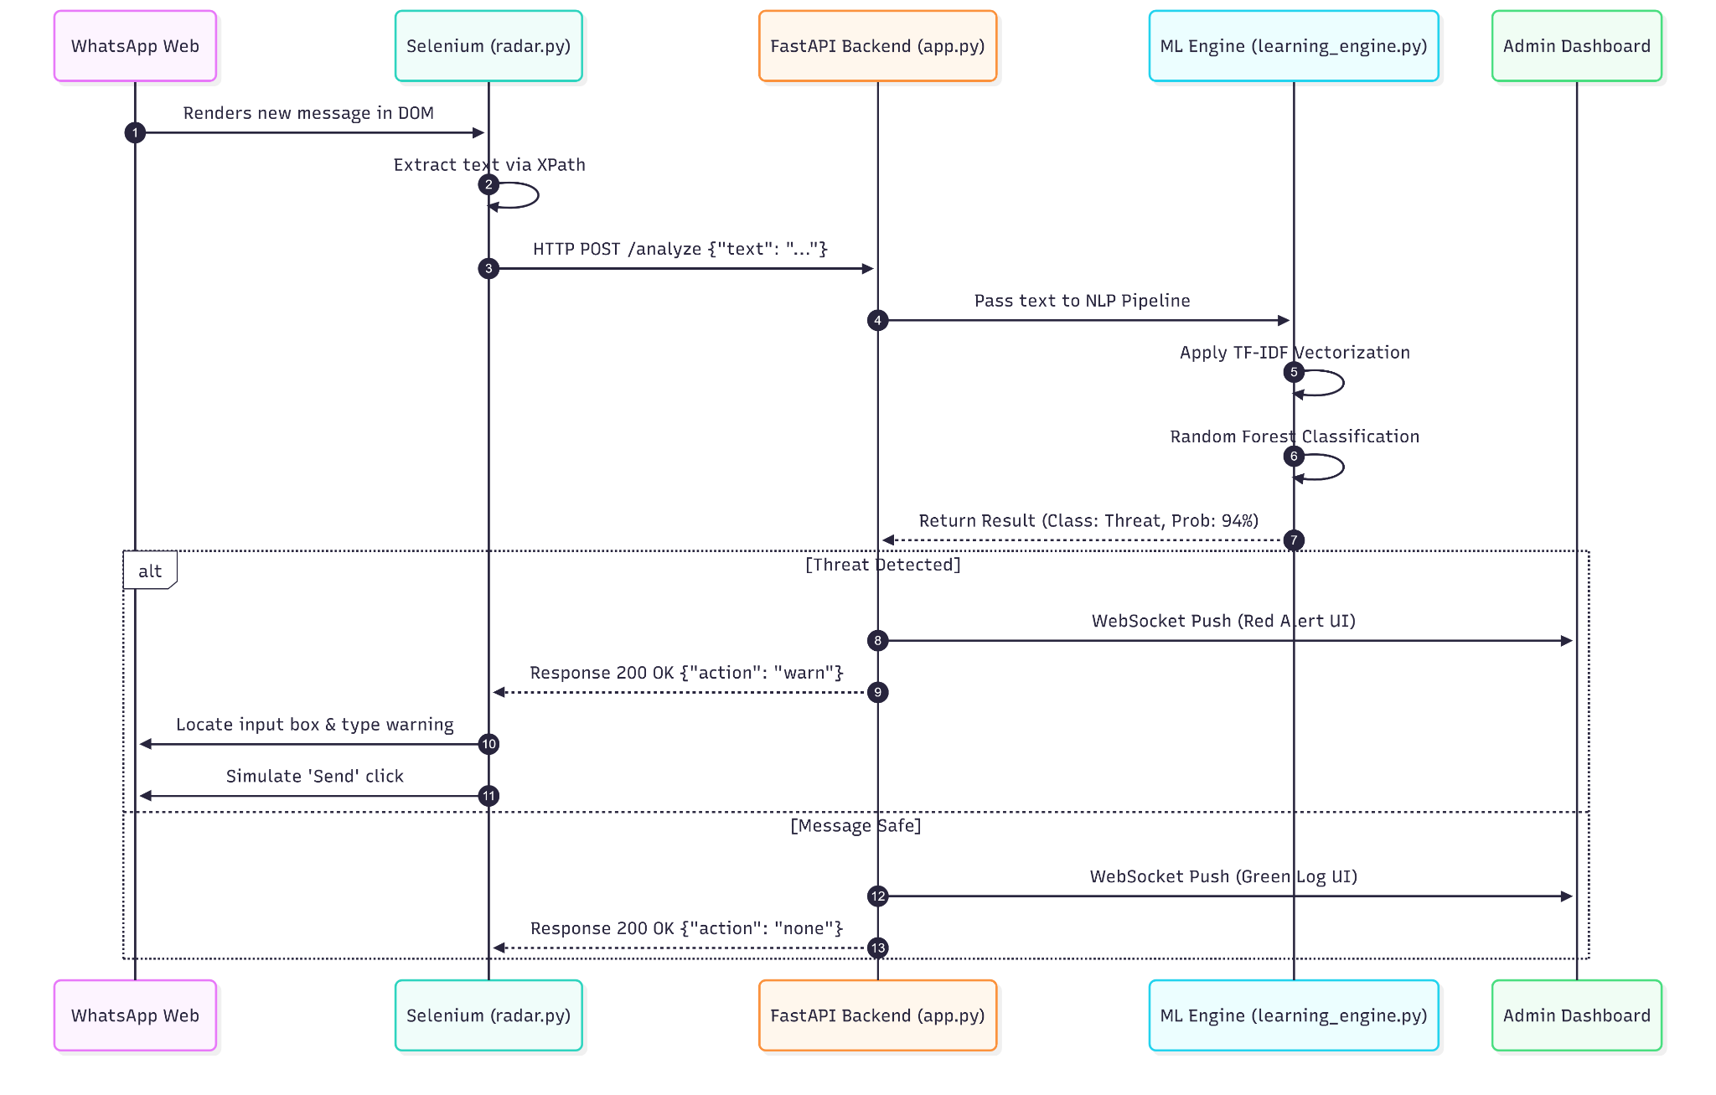

3.8 System Testing and Evaluation Strategy
To scientifically validate the efficacy of the framework before live deployment, rigorous evaluation metrics must be established. The machine learning model will be evaluated based on the standard Confusion Matrix criteria.

3.8.1 Confusion Matrix Definitions
- True Positives (TP): The system correctly identified a scam message and issued a warning.
- True Negatives (TN): The system correctly identified a normal student message and remained silent.
- False Positives (FP): The system incorrectly flagged a normal message as a scam (creating a nuisance warning).
- False Negatives (FN): The system failed to identify a real scam message (a severe security failure).

3.8.2 Mathematical Evaluation Metrics
Using the definitions above, the model's performance will be quantified using the following metrics during Phase 5 testing:
- Accuracy: The overall correctness of the model across the entire dataset.
- Precision: The ratio of correctly predicted positive observations to the total predicted positives. High precision relates to a low false-positive rate.
- Recall (Sensitivity): The ratio of correctly predicted positive observations to all observations in the actual class. In cybersecurity, high recall is crucial to ensure no threats slip through.
- F1-Score: The weighted average of Precision and Recall, providing a balanced metric especially useful when datasets are unevenly distributed.

3.9 Hardware and Software Requirements
The development and deployment of the Intelligent Management Framework require the following specifications to ensure optimal performance and real-time processing capabilities.

3.9.1 Hardware Requirements
Component | Minimum Specification | Recommended Specification (for Deployment)
Processor | Intel Core i5 / AMD Ryzen 5 | Intel Core i7 / AMD Ryzen 7
RAM | 8 GB | 16 GB (Required for heavy Selenium instances)
Storage | 256 GB SSD | 512 GB NVMe SSD
Network | Stable Broadband (10 Mbps) | High-Speed Fiber (100+ Mbps for low latency)

3.9.2 Software Requirements
Component | Technology / Library Used | Purpose
Operating System | Windows 10/11 or Ubuntu Linux | Development Environment
Programming Language | Python 3.10+ | Core scripting and backend logic
Web Framework | FastAPI | High-speed, asynchronous API routing
Web Automation | Selenium WebDriver | DOM manipulation and data extraction
Machine Learning | Scikit-learn, Pandas, NumPy | Data preprocessing and model algorithms
Browser Environment | Google Chrome | Rendering WhatsApp Web
Frontend UI | HTML5, JavaScript, WebSockets | Real-time monitoring dashboard

3.10 Chapter Summary
This chapter has provided a thorough, in-depth explanation of the research methodology and system architecture underpinning the Intelligent Management Framework. By adopting an Agile Iterative approach, synthesizing a cross-lingual dataset to handle Manglish, and employing rigorous TF-IDF vectorization coupled with Random Forest classification, the system is mathematically equipped to detect localized cyber threats. Furthermore, the decoupled architectural design—utilizing Selenium for extraction and an asynchronous FastAPI backend for logic—ensures that the framework can monitor university social groups and inject automated warnings in real-time, effectively eliminating the trust-based security gap identified in previous chapters. The subsequent chapter will detail the experimental results, presenting the evaluation metrics and assessing the real-world performance of the system during simulated threat scenarios.

